Information System Design Sessional

**Traffic Control System**

Group No: 4

Student Id: 1005099

1005105

1005110

1005112

1005114

**Subsystems:**

* **Optimal Route Suggestion**
* **Complaint Filed By User**
* **Case-filing By Traffic Police for Violation of Law**

**Data flow diagram:**

**Data flow diagram of Optimal Route suggestion:**

In this diagram external agents are

1. Users
2. Data provider(DP)

In this subsystem there is a data base (route info’s) in which DP will update the current traffic volume in data base by crowd sourcing. Data providing will be triggered by time (after a fixed time interval).

Our external agent ,users will be asked for source and destination input through a process “query route”. This process will extract desired information from our database and calculate optimal path. This result (suggestion) will be sent to the users who did the query by a process “Show suggestion”

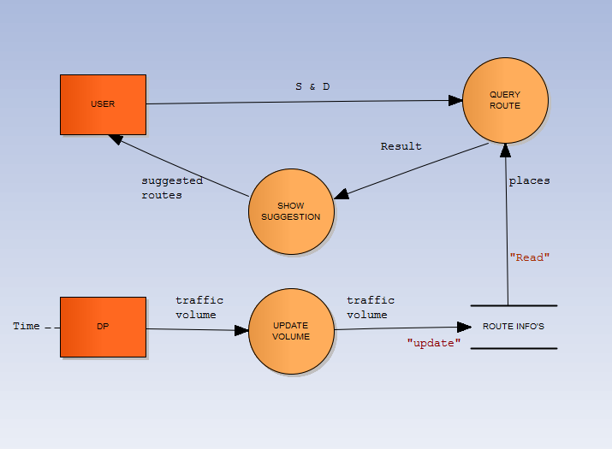

**Data flow diagram of Complaint Filing By Users:**

In this diagram external agents are

1. Users
2. Traffic police
3. Police
4. DMP(Dhaka metropolitan)

In this subsystem there is a “Complaint Book” in which Users will provide the information (Complainant, accused, complaint description, complaining zone) regarding complaints to our process “file complaint”; this process will return our users a “Complaint number”. This will also handle our database and create new complaints to database .Higher authorities of DMP will read the complaints through our process “view complaints”. Decision made by higher authorities will be updated in our database through process “make decision”. Higher Authorities (DMP) send command (verify) to our External agents (TP, P) to investigate the complaint and give feedback to them. Based on the feedback, the higher authorities will decide whether it will remain a complaint otherwise it will be sent to one of our subsystem “**Case-filing By Traffic Police for Violation of Law”.**

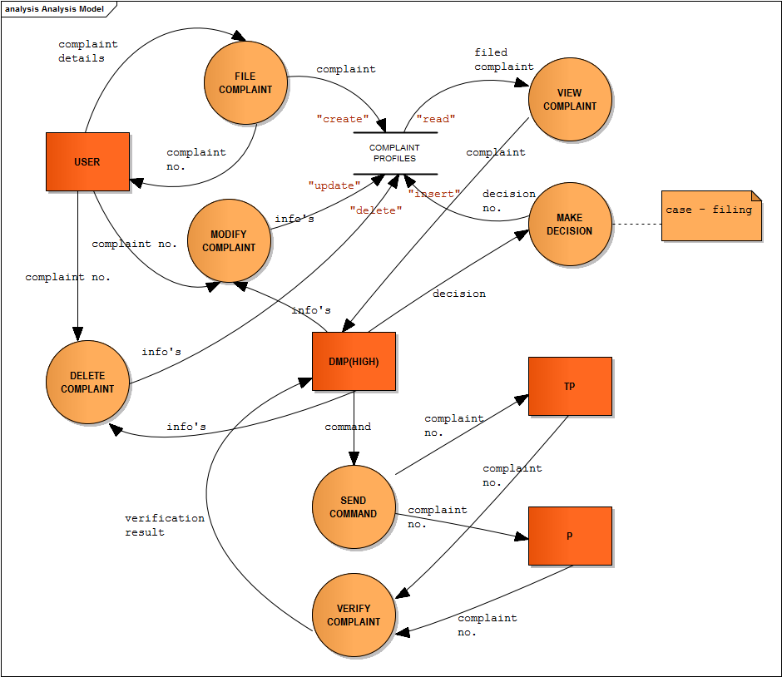

**Case Filing By Traffic Police for Violating Traffic Rules**

In this diagram external agents are

1. Users
2. Traffic police
3. DMP(Dhaka Metropolitan Police)

In this subsystem, traffic police sends case information to DMP. There is a database “Basic Profiles” in which DMP will make query to get the driver profile information through the process “Make Query” and then file a case in the database “Case Book”. Here, traffic police and user can view the list from the database through the process “Show”.

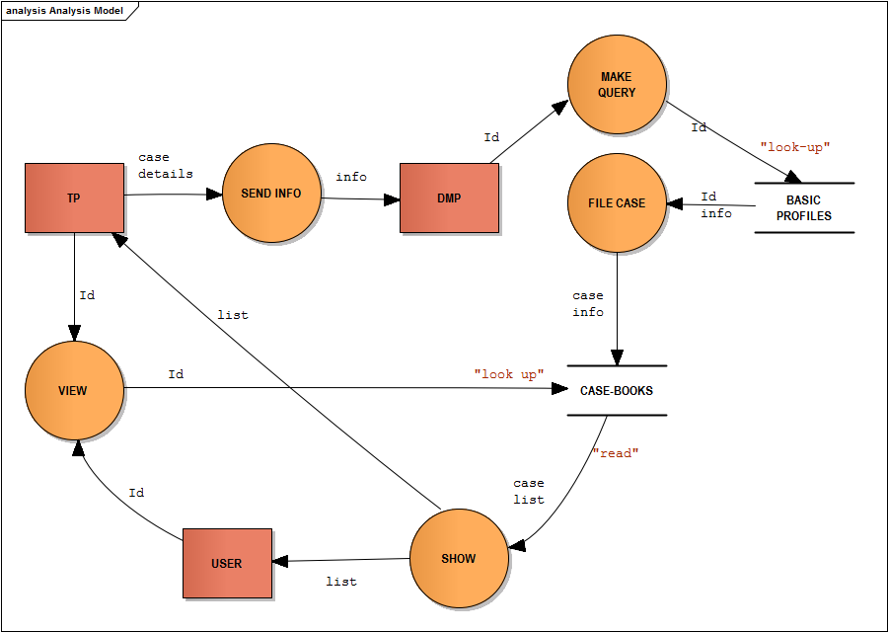

**Fishbone Diagrams:**

**Fishbone Diagram for Optimal Route Suggestion**

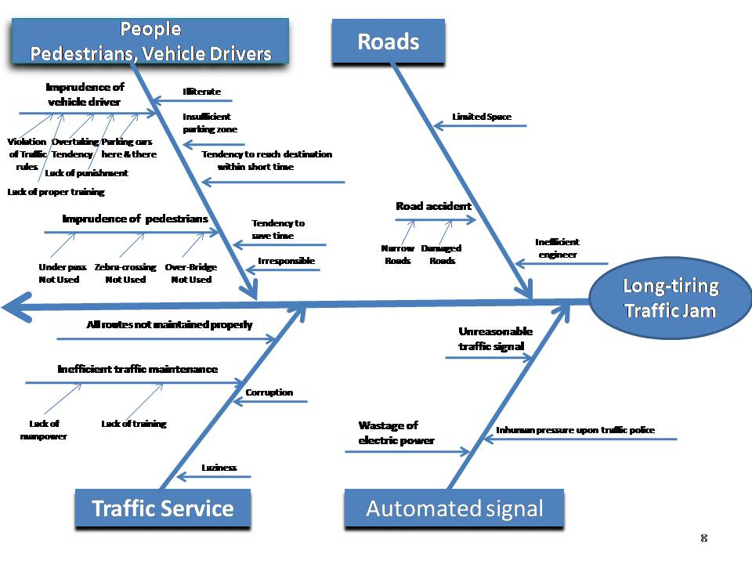

**Fishbone Diagram for Complaint Filing By Users**

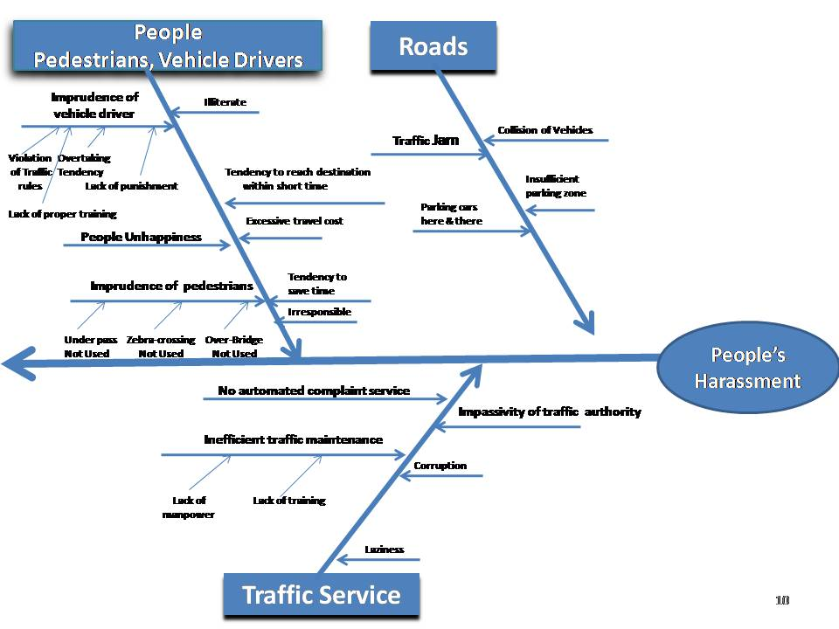

**Fishbone Diagram for Case-Filing for Violation of Law**



**Feasibility Analysis:**

Feasibility denotes to the measurement of how much beneficial or practical an information system will be to an organization.

Depending on the requirement of our clients, the feasibility of our proposed system is discussed below based on the four basic tests of feasibility-

* Operational Feasibility
* Technical Feasibility
* Economic Feasibility
* Cultural Feasibility

**Operational Feasibility:**

* The well arranged and properly controlled system database would help the administrators to a great extent to keep all the records and for further queries.
* For implementing this system there are some important things that we need to discuss :
* **Training Up Existing Persons :**

Most of the existing employees i.e. - traffic police, DMP staffs are not that much familiar with computers. So all of them should be trained and made familiar with computers. The training will not be over after making them familiar with the computers. We also have to make them familiar with how to use our system.

* **Appointing IT experts:**

After the training is completed the central database system should be maintained properly. So traffic authority needs to appoint IT experts who will inspect the whole system and help the traffic police and DMP staffs to assist in their technical jobs.

**Technical Feasibility:**

DMP uses some of the very modern and new technologies for controlling traffic system. But at present they don’t have any technical support for establishing a fully automated system for the administrative and service section. Based on their present condition the technical feasibility can be discussed in three parts:

**Hardware Availability and Requirement:**

* Though they have some computers for technical uses, they have to buy some high configuration computers for setting up the central sever.
* They also need to set up an internal LAN connection for maintaining the interconnection between different sections.

**Software Availability and Requirement:**

* At present, DMP maintains almost everything by paper works. So there is no such software to maintain this system fully.
* They need to maintain a huge database system. So for this we propose the ORACLE database for storing the information properly.
* There must have been a good backup of software.
* As the Windows Operating system is more users friendly and most of the employees of DMP don’t have enough knowledge for operating computers we propose that computers should have windows as their operating system.
* Now the normal users won’t be able to control virus attack in the PC so good antivirus software should also be installed.

**Technical Manpower Availability:**

* Though some of the employees of DMP have enough knowledge for operating such a system, most of the traffic police and other staffs of DMP don’t have that knowledge. So from present condition technical manpower availability is none.
* In our proposed solution we suggest to appoint an IT expert so after installing the system there will not be problem for maintaining the server.
* As we proposed for training for all the traffic police and other employees of DMP, there will not be any problem for them for doing their respective operations.

**Economical Feasibility:**

Cost & Benefit Analysis:

Costs can be categorized in two ways. There are costs associated with developing the system, and there are costs associated with operating a system. The former can be estimated from the outset of a project and should be refined at the end of each phase of the project. The latter can be estimated only after specific computer-based solutions have been defined. Overall cost is mainly of two types.

The Onetime costs for developing the system are-

* New hardware installation
* Training of the personnel
* Development Cost for the system

The Annual Costs would be-

* Salaries for new recruitments.
* Costs for Computer Usage and supplies

DEVELOPMENT COSTS:

The Costs of developing our information system can be classified in three phases-

**Expenses for Software Developers:**

|  |  |  |  |
| --- | --- | --- | --- |
| Number of Employees | Type of the Employee | Time Period | Total money (taka) |
| 3 | System analysts  (30,000 taka /month) | 1 year | 10,80,000 |
| 5 | Programmer/analyst (20,000 taka /month) | 3 months | 3,00,000 |
| 1 | GUI designer  (10,000 taka /month) | 3 months | 30,000 |
| 1 | System architect  (50,000 taka /month) | 1 month | 50,000 |
| 2 | Communication specialist (30,000 taka /month) | 1 month | 60,000 |

**Expenses for Training:**

|  |  |  |  |
| --- | --- | --- | --- |
| Number of Employees | Type of Training | Time Period | Total money (Taka) |
| 15 | Computer Training (2000 Taka/person) | 4 months | 1,20,000 |

**Expenses for New Hardware and Software:**

|  |  |  |
| --- | --- | --- |
| Number of Equipments | Type of Equipments | Total money (Taka) |
| 20 | Computer accessories | 5,00,000 |
| 5 | LAN equipments | 1,00,000 |

|  |
| --- |
| **22,40,000**  Taka |

**Total Development Cost:**

Table 4.2: Development cost distribution table

Projected Annual Operating Costs:

**Personnel:**

|  |  |  |  |
| --- | --- | --- | --- |
| Number of Personnel | Position | Working Hour | Cost |
| 2 | Programmer Analysts | 5 | 10,000 Taka |

**Expenses:**

|  |  |  |
| --- | --- | --- |
| Number of Items | Requirements | Cost |
| 1 | Maintenance Agreement of Server | ** |
| 1 | Maintenance Agreement for Server DBMS Software | ** |
| ** | Necessary Hardware Components | ** |

Table 4.3: Project annual cost distribution table

**Financial Strength:**

DMP is a government organization. So the costing depends totally on the government willing of accepting the project. Sometimes DMP also gets helps for different project from different organizations. Besides, DMP also gets some foreign aids from different countries government.

**Cultural Feasibility:**

* In this automated system, it is required that DMP do any kind of paperwork no more. They need to update or create a main database record with the total information of our traffic system. But this system may not be liked by aged employees of DMP and common people for the lacking of their computer skill. Even many employees of DMP may not like the computer training.
* Many of the old but reliable employees of DMP may not be able to learn the automated system. Then they may have a fear of losing their jobs, which may affect their duties.
* The creation of some new IT post may not be liked by all of the employees. In that case the IT expert may face unfriendly and uncooperative behaviors from other employees which may hamper the overall employee management system of DMP.

Benefits

# Tangible Benefits

* **Proper Management of Drivers’ & Vehicle Owners’ Information**

The system will be designed in a way that it will store vehicle record with all necessary details. So it becomes very easier for authorities to get drivers/owners previous history. Each time users interact with this system, they will be able to update their necessary details.

* **Comfortable travelling**

Nowadays journey to any place becomes more tiring and time consuming because of traffic jam. Traffic jam affects our daily life. As this system provides the users a route based on shortest time and shortest distance, this would make their journey more comfortable.

* **Harassment-free journey**

Most of the time many unwanted events create traffic jam such as- collision of two cars in the street. Then without traffic police the situation cannot be handled. But in such scenario, the traffic police are seen to be involved in taking complaints rather than handling the traffic jam. As in this system, the complainant can directly make a complaint without involving the traffic police; this will lessen the harassment of common people in the street due to traffic jam.

* **Tracing a vehicle easily**

As this system keeps a database for storing vehicle owner and driver information, so it will be lot easier to trace a car for case filing and other reasons. This will help police and traffic police a lot.

* **Job opportunity for people**

In this system, the optimal route suggestion requires traffic volume update frequently. As this will be done by crowd sourcing, it will require a lot of manpower. This can pave a way for the unemployed for better job opportunities.

## Intangible Benefits

* **Improved Traffic Police’s Responsibility**

This automated system keeps track of vehicles and user complaints and also traffic police’s activity on some matter. So, all the traffic police will become more sincere in performing their duty. Again all the officers will also be punctual as their action will be viewed by higher authorities. This will make them honest and sincere. This will help common people a lot and also increase the reputation of the traffic system.

* **Better Technological Knowledge**

As the employees will be trained and made familiar with computers and internet, their knowledge will increase and so will their efficiency. If the users are able to use computers and internet then the whole traffic system can get to more advanced level.

* **Corruption-free Environment**

In case of any incident in the road, most of the time the accused gets advantage because of corruption among traffic police. Giving bribe to the traffic police, they dismiss the matter. As this system offers the complainant to file a complaint which will be handled by the higher authorities of DMP, this will without doubt create a corruption-free atmosphere in our country.

* **Development**  **of morality in mass people**

Common people will find this automated traffic system very helpful in their daily life. This will encourage them to follow and maintain the traffic rules sincerely. And in case of any violence of rules such as wrong car parking, over-taking tendency or reckless driving, they will protest against the rule violators as the process will be very easy than the current situation. This will develop their morality.

* **Improvement of the reputation of traffic system**

In this system, the whole traffic system will be maintained digitally. All time-consuming, hand-written paper works will be in the tip of hands. No chance of bribery or any corruption will exist there. Mass people’s satisfaction towards this system will increase the reputation of the traffic system of our country.